6D5N Beijing-Shanghai Tour

Period : Jan-June, 2020
Pax : 15-30Adults+1Foc
Hotel : Local 4 star or similar
Meal : No pork meal

D1:Beijing (--/L/D) ETA in the morning
Upon arrival in Beijing, meet the local services,visit Tian An Men Square, Forbidden City,Niujie Mosque，Acrobatic Show. After dinner go to hotel.
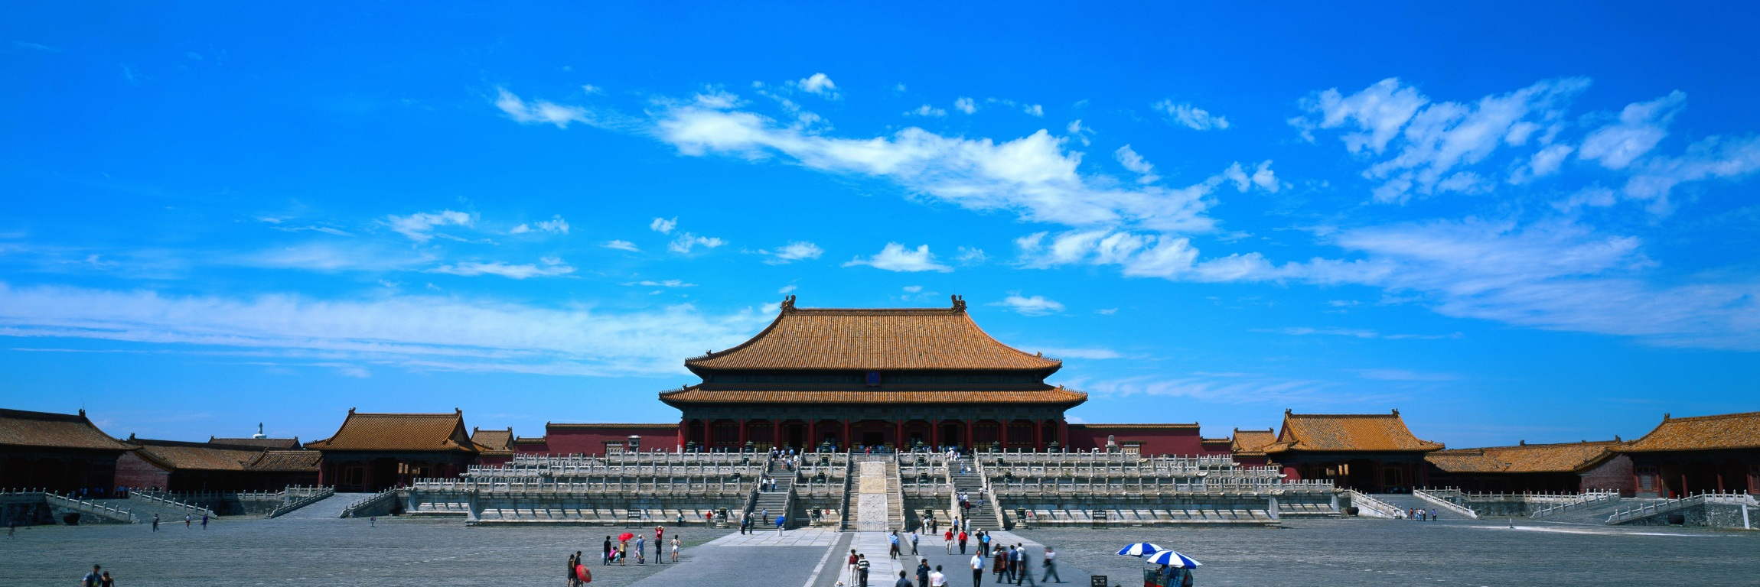
D2: Beijing (B/L/D)
After Breakfast in the hotel,visit Great Wall,Outside Beijing 2008 Olympic National Stadium (Bird Nest& Water Cube),Dinner with Peking Roast Duck . After dinner go to hotel.
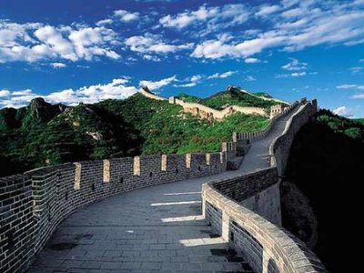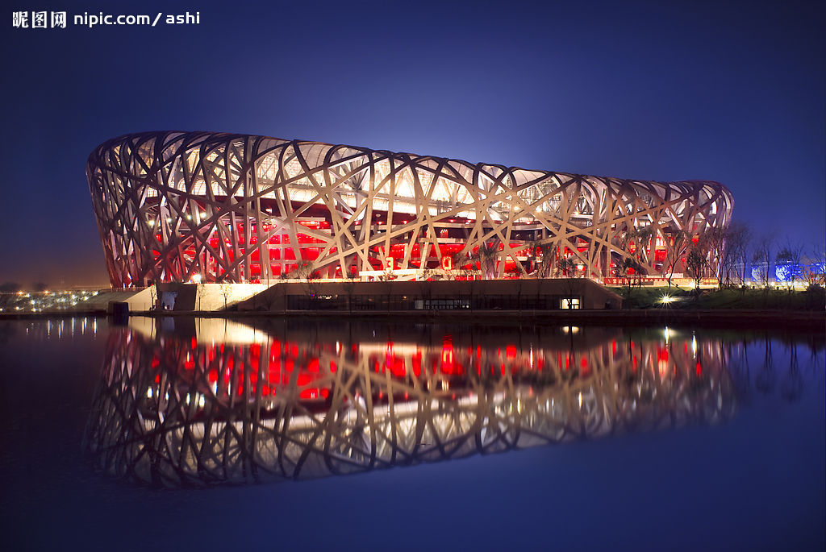
D3：Beijing (B/L/D)
After Breakfast in the hotel,visit Summer Palace,Dongsi Mosque,Panda House. After dinner go to hotel.
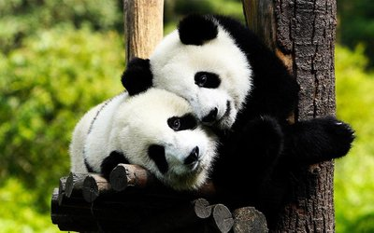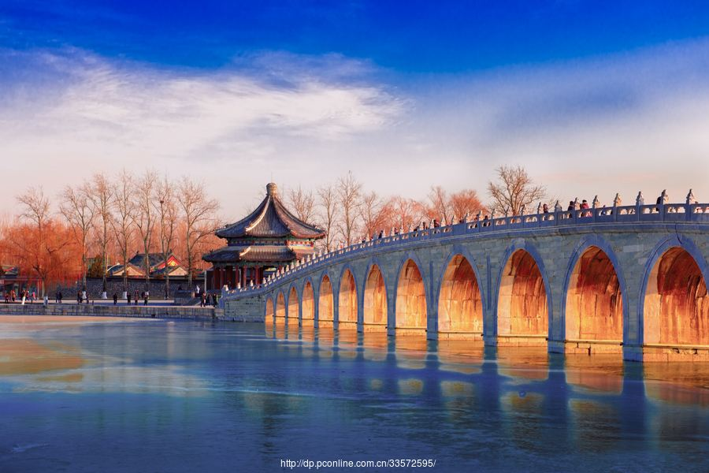

D4: Beijing-Shanghai (B/L/D) by 2nd Bullet Train 5h
After Breakfast in the hotel,transfer to Shanghai,visit The Bund,Nanjing Road,Outside Oriental Pearl TV Tower for photo stop,Xiaotaoyuan Mosque. After dinner go to hotel.
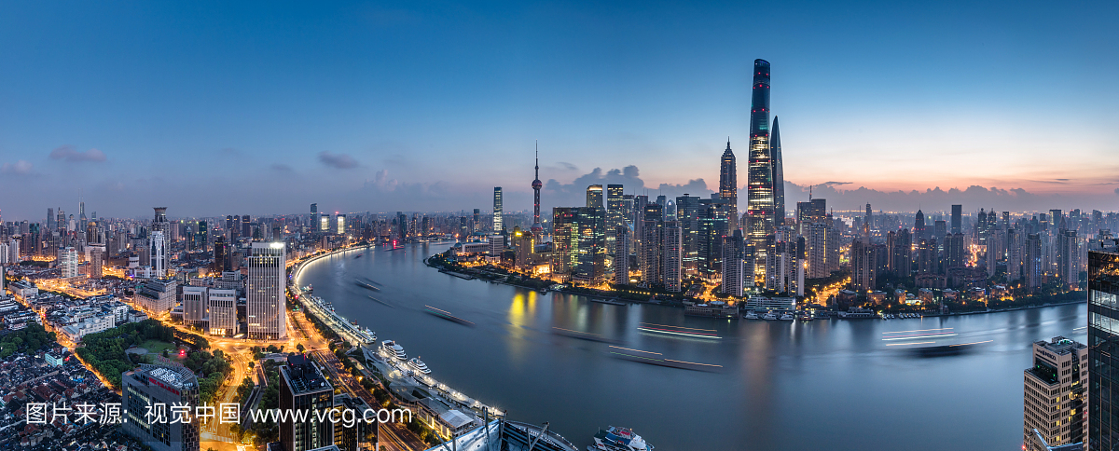
D5:Shanghai (B)
Full free day in Shanghai Disneyland.

D6: Shanghai-Departure (B/-/-)
After Breakfast in the hotel,transfer to the airport and end the tour.

Shopping stop:
Beijing: Chinese Medicine Center (Foot Bath), Baoshutang, Latex,Tea
Shanghai:Jewelry
Hotel 4****local or similar
Beijing: Apple Hotel or similar
www.sijiapplehotel.com
Shanghai:Gardenia Hotel or similar
https://hotels.ctrip.com/hotel/2216873.html#ctm_ref=www_hp_bs_lst

Jan-Feb
PAX | 4 STAR (per pax)
PAX | TWN（USD） | SGL SUPL（USD） | CWB(USD) | CNB(USD)
15--30+1 Foc | 160 /pax | 90 | 145 | 120

Mar
PAX | 4 STAR (per pax)
PAX | TWN（USD） | SGL SUPL（USD） | CWB(USD) | CNB(USD)
15--30+1 Foc | 170/pax | 100 | 155 | 130

Apr-June
PAX | 4 STAR (per pax)
PAX | TWN（USD） | SGL SUPL（USD） | CWB(USD) | CNB(USD)
15--30+1 Foc | 185/pax | 105 | 170 | 140
Due to this price is for shopping tour,the paxs under 25 years old should not be over 20% of whole group,otherwise should contact us for new price.

The above quotation included:
1. Transfer in/out
2. Meals
3. Indonesian speaking guide and entrance fee
4. Accommodate in local 4 star hotel
5. Free 1 Bottle of water /Pax/day
6. Accident Insurance
7. Peking Roast Duck

The above quotation excluded:
1. International flight ticket and airport tax
2. Tips for the guide and driver 4USD/Day/Pax. (Above 10 pax)
3. Tips for potter, waitress & Luggage’s fee
4. Personal consumptions & expenses (laundry, phone, mini bar, etc)
5.2nd Bullet ticket Beijing-Shanghai:85USD/pax no foc.
6 Entrance fee of Shanghai Disneyland on Summer Holiday (July--August) & Weekend $85/pax No Foc. On weekday $60/pax No Foc.

